CLASS CREATOR
12.06.2020
V_01

Introduction
If you are someone who writes custom editors, creating too many editor scripts can be a bit annoying. Because the Unity does not help it, and you need to write a script for each type. In this case, the asset of 'Class Creator' comes to your aid. Using this asset, you can create not only the editor but also the 'ScriptableObject' file and ‘Monobehaviour’. Of course, quickly and easily ... :)

Let's get create a script.

C#
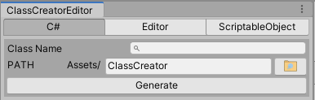
Class Name: Name of your Monobehaviour script. If you write this field you will see open the search field. This field listining all Monobehaviour script names your project.

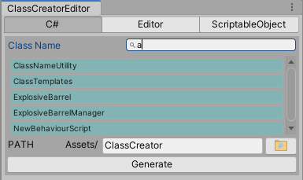

Editor
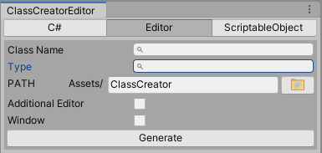

Type: The type of the class to create its editor. You can search within this process as in the class name field.

Additional Editor: Adds the 'Editor' at the end of your class name.

Window: You can create an 'EditorWindow' if you want. When this option is active, you will need to select 'ItemName' additionally.

ScriptableObject
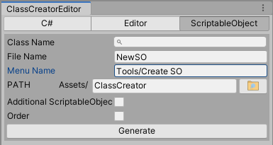

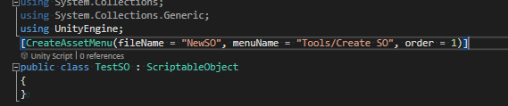
Author:
Atilgan Sak – Unity Developer

